**NAME: Ahmed Mohamed Zekry Herdash**

**B.N: 120**

**Date: 31/5/2020**

**Topic: Big Data**

**Github-link:**

**Github – page:**

**Application Brief :**

***Big Data*** is a phrase used to mean a massive volume of both structured and unstructured data that is so large it is difficult to process using traditional database and software techniques. In most enterprise scenarios the volume of data is too big or it moves too fast or it exceeds current processing capacity.

***An Example***

An example of big data might be [petabytes](https://www.webopedia.com/TERM/P/petabyte.html) (1,024 terabytes) or [exabytes](https://www.webopedia.com/TERM/E/exabyte.html) (1,024 petabytes) of data consisting of billions to trillions of records of millions of people—all from different sources (e.g. Web, sales, customer contact center, social media, mobile data and so on). The data is typically loosely structured data that is often incomplete and inaccessible.

## The Benefits of Big Data Analytics

Enterprises are increasingly looking to find actionable insights into their data. Many big data projects originate from the need to answer specific business questions. With the right big data analytics platforms in place, an enterprise can boost sales, increase efficiency, and improve operations, customer service and risk management.

Webopedia parent company, Quintet, surveyed 540 enterprise decision-makers involved in big data purchases to learn which business areas companies plan to use Big Data analytics to improve operations. About half of all respondents said they were applying big data analytics to improve customer retention, help with product development and gain a competitive advantage.

Notably, the business area getting the most attention relates to increasing efficiency and optimizing operations. Specifically, 62 percent of respondents said that they use big data analytics to improve speed and reduce complexity.

## *Business Datasets*

When dealing with larger datasets, organizations face difficulties in being able to create, manipulate, and manage big data. Big Data is particularly a problem in business analytics because standard tools and procedures are not designed to search and analyze massive datasets.

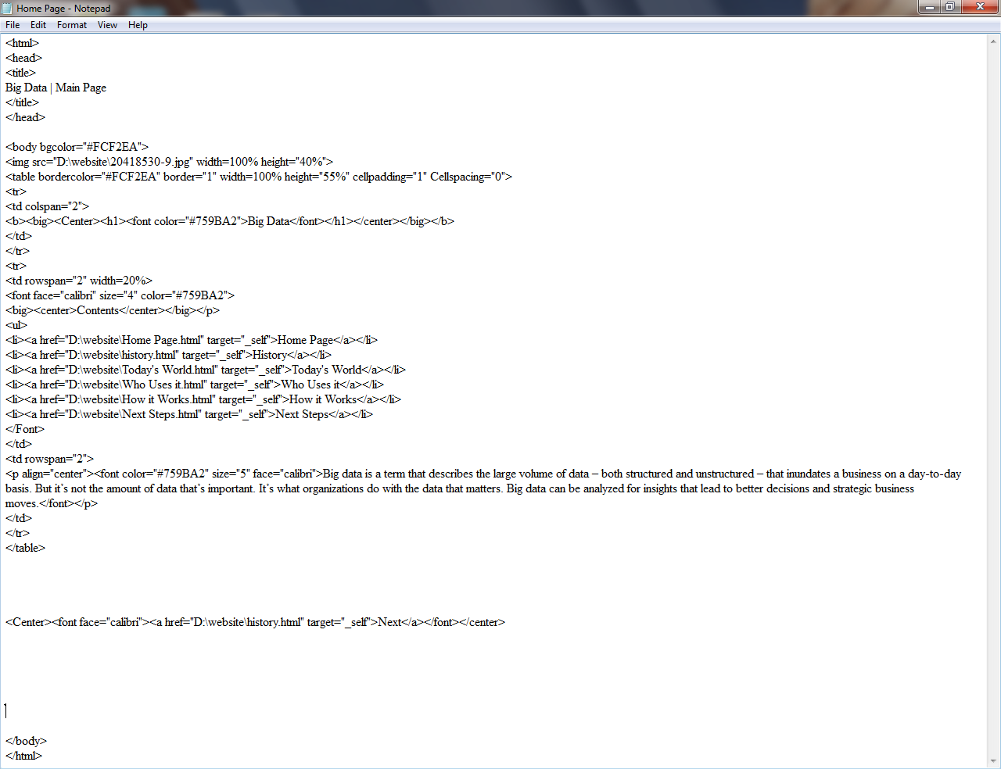

**Source code:**

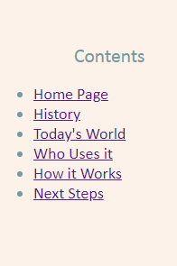**Screenshots :**

